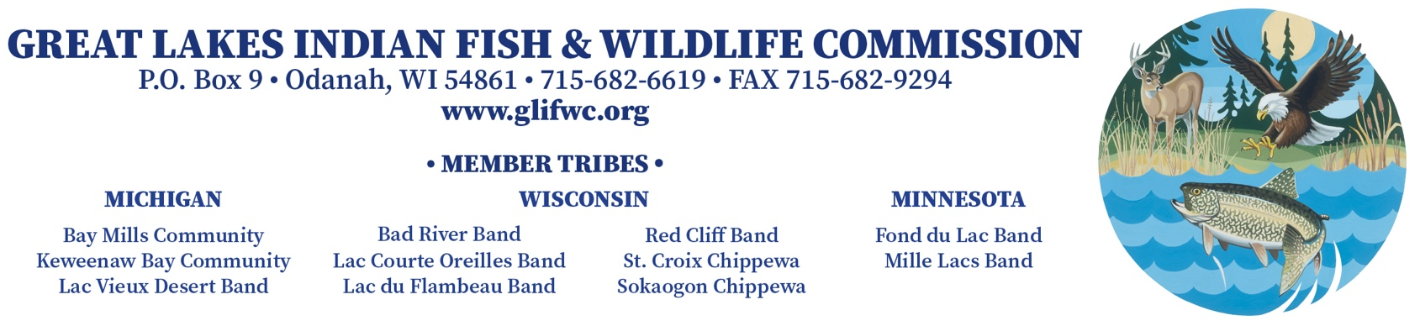
FOR IMMEDIATE RELEASE February 22, 2021

GLIFWC tribes respond to recent Ma’iingan Decision

Urge the state for consultation, wolf protection and science-based natural resource decision-making

As wolf management in Wisconsin is occurring in a highly politicized environment, GLIFWC member tribes continue to advocate for an inclusive and deliberative decision-making process about shared resources.

Ma’iingan (my-ing-gaahn) is the Anishinaabe word for wolf. Wolves are revered as relatives in the Ojibwe lifeway. Ma’iingan serves as a clan icon – a representation of traditional governance and organization within the community.

“We are extremely disappointed with the recent decisions and we petition the State and Natural Resources Board to follow both sound and current science and follow the co-management framework laid out in the LCO v. Wisconsin [or Voigt] case,” said Voigt Intertribal Task Force Chairman John Johnson. “We are growing tired of the lack of tribal consultation on issues that directly impact our sovereign nations.”

Federal court decisions require the state to coordinate management with the plaintiff tribes in the LCO v. Wisconsin case and consult them on decisions that impact their treaty-reserved rights in treaty-ceded territories.

The controversial season begins today and ends February 28th. The “harvest” is occurring in the absence of an updated management plan, without the required input of tribes with treaty-reserved rights, and in violation of agreements made in the LCO case. It is also occurring in the absence of buffer zones around each reservation that would help safeguard packs that live partially on reservation – packs that tribes have worked hard to protect. To many Ojibwe communities, hunting in late February, a time when fur quality is poor and wolves are in their breeding season, is regarded as especially wasteful and disrespectful.

Tribes look forward to continuing their relationship with ma’iingan while working with the State of Wisconsin and all interested parties in improving ma’iingan stewardship for the health of ecosystems and for the benefit of future generations.

Contact GLIFWC Public Information Office: Dylan Jennings (715) 348-6594 or Charlie Rasmussen (715) 209-1607.

