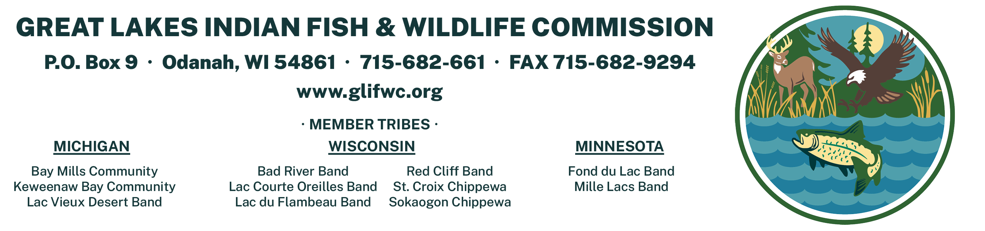
JOB ANNOUNCEMENT

JOB TITLE: American Marten Hair Snare/Trapping Technician (2 positions)

LOCATION: Eagle River, WI and Cable, WI

CLASSIFICATION: Limited Term Employment (LTE)

SALARY: $15/hr. (up to 40 hours a week) Field housing provided.

POSTING DATE: OCTOBER 15, 2026
CLOSING DATE: OCTOBER 30, 2026

JOB SUMMARY:
The University of Wisconsin-Madison, in cooperation with the Great Lakes Indian Fish & Wildlife Commission (GLIFWC), is recruiting 2 hair snare/trapping technicians to conduct American marten surveys in the Chequamegon-Nicolet National Forest. Technicians will assist a PhD student in conducting non-invasive hair snare surveys alongside trapping and collaring marten. The anticipated start date is 02-January with an expected end date of 28-February-2027, though there is a possibility of additional work. Housing and field vehicles are provided.

RESPONSIBILITIES:
Duties may include, but are not limited to:
- Installing and checking hair snare stations.
- Installing and checking trail camera stations.
- Conducting live trapping and collaring of American marten.
- Downloading, sorting, and identifying species in trail camera photos.
- Entering, proofing, and summarizing field data.

QUALIFICATIONS
- Experience collecting and maintaining field data in an organized manner that is easily understood and accessible to others
- Ability to live and work in a rural and remote field and office setting
- Able to carry personal and/or field equipment, and withstand the rigors of a rugged work environment
- Willingness and ability to consistently enact high-performance standards and a strong work and team ethic.
- Ability to use GPS to navigate to and within field sites
- Valid US Driver’s License
Preferred Qualifications:
- Experience trapping and handling wildlife
- Experience working in winter environments
- Experience navigating and collecting spatial data with hand-held GPS units
- Previous experience working outdoors and driving in cold and snowy winter conditions

Indian preference will be applied consistent with GLIFWC policies and the Indian Self Determination and Education Assistance Act (PL 93-638).

APPLICATION PROCEDURE: Applications can be picked up from GLIFWC's office in Odanah, WI and are also available at www.glifwc.org under the employment tab. Applicants must submit a completed GLIFWC primary application for employment, letter of interest, and resume (including three professional references).

Completed applications & materials should be returned (in person, by mail or email) to:

Ashley Poch, Human Resources Director
Great Lakes Indian Fish & Wildlife Commission
P.O. Box 9, 72682 Maple Street, Odanah, WI 54861 hr@glifwc.org

